**Software Engineering Assignment**

**MODULE: 1 (SDLC)**

**1. What is software? What is software engineering?**

🡪 Software refers to the programs and data that run on a computer system, which instruct the computer to perform various tasks and solve specific problems.

Software engineering is the process of designing, developing, testing, and maintaining software, using systematic and structured methods to ensure that the software is reliable, efficient, and easy to use. This involves applying engineering principles to the software development process, including requirements analysis, design, coding, testing, and documentation.

**2. Explain types of software.**

🡪There are five types of software -

1. Application software.
2. System software
3. Driver software
4. Programme software
5. Middleware Software
6. Application Software: This includes programs that users interact with directly to perform specific tasks, such as word processors, web browsers, and video games.
7. System Software: This includes operating systems, firmware, and other software that manages and controls the computer hardware.
8. Driver Software: Driver software is a type of system software that is used to communicate with and control hardware devices, such as printers, scanners, and graphics cards. A driver is a program that acts as an interface between the hardware device and the operating system, allowing the device to function correctly and efficiently.
9. Programme Software: This includes tools used by software developers to create, debug, and maintain software, such as integrated development environments (IDEs), compilers, and debuggers.
10. Middleware Software: Middleware software is a type of software that acts as a bridge between different applications or systems, allowing them to communicate and exchange data with each other. Middleware provides a set of services and functionalities that simplify the development of distributed applications and enable interoperability between different platforms and technologies.

**3. What is SDLC? Explain each phase of SDLC.**

🡪 SDLC stands for Software Development Life Cycle, which is a framework that describes the stages involved in developing software, from its conception to its deployment and maintenance. The typical stages of SDLC include requirements gathering, Analysis, design, implementation, testing, and maintenance. The SDLC is used by software development teams to ensure that the software is developed systematically, with quality and efficiency in mind, and to provide a structure for project management and communication.

1. Requirement Gathering: This is the first stage where the software development team identifies, documents, and analyses the requirements of the software system to be developed. This involves understanding the needs and goals of the users, as well as the technical and business requirements for the software. The output of this stage is a requirements document, which serves as a foundation for the subsequent stages of the SDLC.
2. Analysis: In this stage, the software development team examines and evaluates the requirements gathered in the previous stage. The goal of analysis is to ensure that the requirements are complete, consistent, and feasible.
3. Designing: In this stage, the software development team uses the requirements and constraints identified in the previous stages to design the architecture, components, modules, and interfaces of the software system. The design stage can be divided into two parts: high-level design and detailed design.
4. Implementation or Coding: In this stage, the software development team starts to write the code based on the design specifications. The implementation stage involves converting the design into a working software system, writing code, and integrating components.
5. Testing: In this stage, the software system is tested to ensure that it meets the requirements and specifications. The testing can be done manually or through automated testing tools, and it includes functional testing, performance testing, security testing, and other types of testing.
6. Deployment: In this stage, the software system is deployed to the production environment or released to the customers. This involves installing the software on the end-users' systems and ensuring that it works correctly in the production environment.
7. Maintenance: In this stage, the software system is maintained and updated to ensure that it continues to meet the requirements and operates effectively. This includes bug fixes, updates, and new features or functionalities that may be needed to adapt to changing user needs or new technological developments.

**4. What is DFD? Create a DFD diagram on Flipkart.**

🡪 DFD stands for Data Flow Diagram. It is a visual representation of a software system that shows the flow of data and the processes that manipulate it. A DFD is a tool used in system analysis and design to model the flow of data within a system.

A DFD consists of four main components: data sources and destinations, data stores, processes, and data flows. Data sources and destinations represent the external entities that send or receive data to or from the system. Data stores represent the repositories where data is stored within the system. Processes represent the operations that are performed on the data, and data flows represent the movement of data between the components.

DFDs are used to analyse the requirements of a system and to identify potential sources of errors or inefficiencies. They are useful for communicating system design to stakeholders and for ensuring that the development team understands the system requirements. DFDs can be used to model both manual and automated systems and can be used in conjunction with other tools, such as use cases, to fully capture system requirements.

**0 level DFD**

**Request For Login Request For Registration**

User

Admin

**Response Response**

**1st Level DFD**

Generate System User Report

Generate Shipment Report

Generate Product Report

Generate Shopping Cart Report

Generate Shipping Report

System User Management

Shipping Cart Management

Check User Login Detail

Login Management

Ship Management

Product Management

Shopping Management

**2nd level DFD**

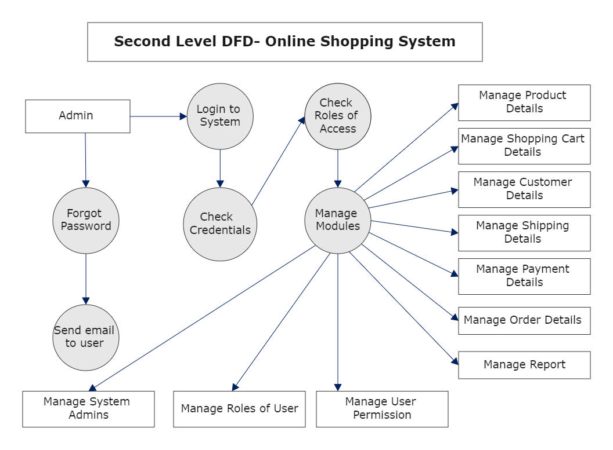

**5. What is Flow chart? Create a flowchart to make addition of two numbers.**

🡪 A flowchart is a graphical representation of a process or algorithm. It is used to visualize the steps involved in a process or program, and to show the flow of inputs, outputs, and decisions made at each step. Flowcharts use various symbols and connectors to depict the different types of actions or decisions in the process. ome of the common symbols used in flowcharts include the start and end point, the process or action, the decision point, the input and output, and the connector or flowline. By combining these symbols, complex processes can be broken down into smaller, more manageable steps, and the flow of inputs and outputs can be traced through the process.

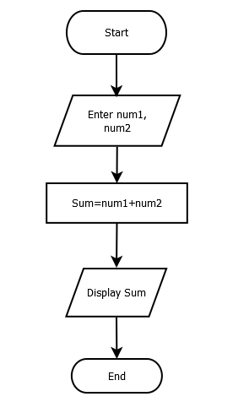

**6. What is Use case Diagram? Create a use-case on bill payment on Paytm.**

🡪 A use case diagram is a type of Unified Modelling Language (UML) diagram that is used to model the interactions between a system and its users or actors. It is a visual representation of the different ways that users or actors interact with the system to achieve specific goals or objectives. In a use case diagram, the actors are represented as stick figures, and the use cases are represented as ovals or ellipses. The use cases describe the actions or functions that the system performs in response to the user or actor's actions. The relationships between the actors and the use cases are represented as lines or arrows. Use case diagrams are often used to help define the requirements for a system, and to ensure that all the necessary functionality has been included in the system design. They can be used to identify potential problems with the system, and to ensure that the system is designed to meet the needs of its users.

